Electronic Detection of Specific Protein
Binding Using Nanotube FET Devices
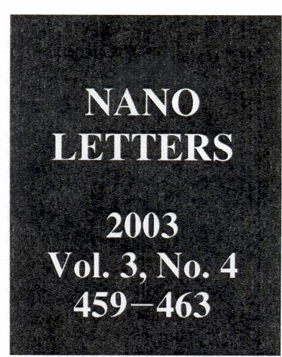

Alexander Star; Jean-Christophe P. Gabriel, Keith Bradley, and George Grüner†
Nanomix Inc., Emeryville, California 94608
Received January 70, 2003; Revised Manuscript Received February 73, 2003
ABSTRACT
We have used nanoscale field effect transistor devices with carbon nanotubes as the conducting channel to detect protein binding. A PEI/PEG polymer coating layer has been employed to avoid nonspecific binding, with attachment of biotin to the layer for specific molecular recognition. Biotin-streptavidin binding has been detected by changes in the device characteristic. Nonspecific binding was observed in devices without
the polymer coating, while no binding was found for polymer-coated but not biotinylated devices. Streptavidin, in which the biotin-binding
sites were blocked by reaction with excess biotin, produced essentially no change in device characteristic of the biotinylated polymer-coated devices.

Current biological sensing techniques commonly rely on optical detection principles that are inherently complex, requiring multiple steps between the actual engagement of
the analyte and the generation of a signal, multiple reagents, preparative steps, signal amplification, complex data analysis, and relatively large sample size. The techniques are highly sensitive and specific but more difficult to miniaturize. Electronic detection techniques may offer an alternative, but their potential has not yet been explored fully. Field effect transistors (FETs) fabricated using semiconducting single
wall carbon nanotubes (nanotube FETs, NTFETs) have been extensively studied.^{1,2} Such devices have been found to be sensitive to various gases, such as oxygen and ammonia, and thus can operate as sensitive chemical sensors. The mech-anism responsible for the change of device characteristic is thought³ to be a charge-transfer reaction between the analytes and the nanotube. NTFET devices,^{3,4} together with devices based on nanowires,⁵ are also promising candidates for electronic detection of biological species. Various groups
have examined the conformational compatibility - driven by size issues as well as hydrophobic effects-between proteins and carbon nanotubes using streptavidin, and found that the protein is able to crystallize in a helical conformation around multiwall carbon nanotubes.⁶. We have also shown⁷ that functionalization of the nanotubes with carboxylic groups, thereby rendering them more hydrophilic, does not lead to protein attachment, thus opening up the avenues for specific-ity. Researchers have also made^v4 some attempts at func-tionalizing single-wall carbon nanotubes to make them biocompatibile, capable of recognizing proteins by using
* Corresponding author. E-mail: astar@nano.com.
On leave from Department of Physics, University of California, Los Angeles.
10.1021/nl0340172 CCC: $25.00 © 2003 American Chemical Society
Published on Web 03/05/2003

noncovalent binding between a bifunctional molecule and
the nanotube to anchor a bioreceptor molecule with a high degree of control and specificity.
In this communication we report taking these advances one step further, by using a sensor architecture that allows the detection of protein-receptor interactions (using biotin-streptavidin binding as an example) and, at the same time, reduces or eliminates nonspecific protein binding. Figure 1 schematically depicts a sensor architecture that uses a NTFET as a transducer; it is covered with a polymer coating that
has hydrophilic properties and onto which biotin is attached. Polymer functionalization in this sensor architecture has several advantages. First, the polymer is used to attach molecular receptor molecules to the sidewalls of nanotubes. Several examples of covalent chemical attachment of bio-logical molecules to nanotubes, including proteins and DNA, have been recently published. ⁸ Covalent modification, how-ever, has the disadvantage that it impairs physical properties of carbon nanotubes. For these reasons we have employed a supramolecular approach, namely, the noncovalent function-alization of carbon nanotubes by employing polymer coat-ings. ⁹ Second, polymer coatings have been shown to modify the characteristics of nanotube FET devices, and thus the coating process can be readily monitored. In particular, coating NTFETs with polyethylene imine (PEI) polymer was found¹⁰ to shift the device characteristic from p-to n-type, presumably due to the electron-donating ability of amine groups in the polymer. Third, the polymer coating could be used to prevent nonspecific binding of proteins. A variety
of polymer coatings and self-assembled monolayers have
been used to prevent binding of undesired species on surfaces for biosensor and biomedical device application. ¹¹ Among
the various available polymers for coating, poly(ethy1ene

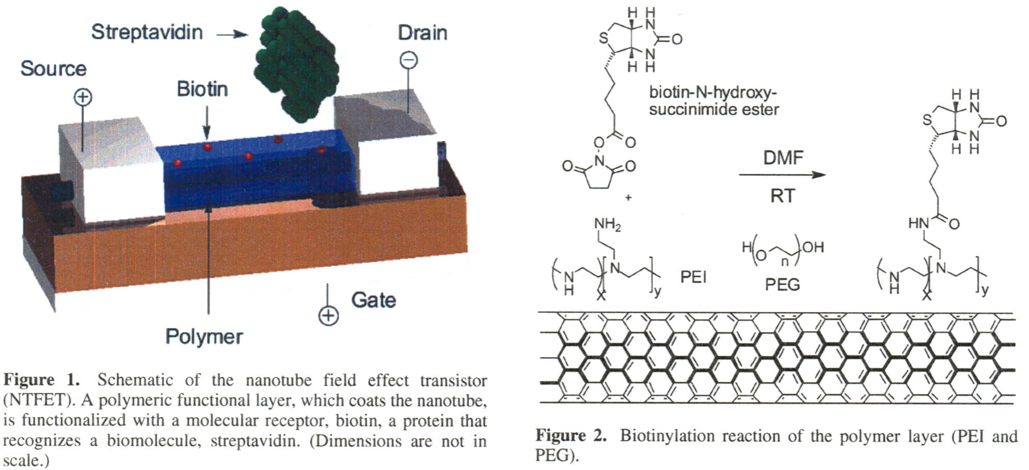

glycol) (PEG) is one of the most effective and widely used.

glycol) (PEG) is one of the most effective and widely used.
This layer, due to its hydrophilicity, reduces the affinity of
nanotubes toward protein binding.
We have chosen the biotin - streptavidin binding to
demonstrate the effectiveness of the device architecture. This binding serves as a model system for protein interactions,¹²
has been extensively studied, and the binding is well
understood. In our procedure, after incubation, the device
was washed and dried, and the device characteristics were
examined after drying. While we have explored the device response in a buffer, our objective here is to examine the changes of the device characteristic, brought about by the
different chemical and biological modifications on the
electronic response, such direct correspondence being some-
what obscured in a buffer environment.¹³
PET devices with nanotubes as the conducting channel
were fabricated using nanotubes grown by chemical vapor
deposition (CVD) on 200 nm of silicon dioxide on doped
silicon from iron nanoparticles with methanehydrogen gas
mixture at 900 ^{O}C; electrical leads were patterned on top of
the nanotubes from titanium films 35 nm thick capped with
gold layers 5 nm thick, with a gap of 0.75 pm between source
and drain. Multiple nanotubes connected the source and drain
electrodes, with the individual tubes varying from metallic
to semiconducting.¹⁴ Consequently, a range of device modulations (expressed as the ratio of the "on" to the "off source - drain current, measured at -10 V and +10 V gate voltage, respectively) were observed. The devices displayed
p-type transistor behavior, as has also been observed by others. ^{1,2} In this paper we have examined the dependence of
the source - drain current, I_{sd}, as a function of the gate voltage V_{g}, I_{sd} (V_{g}), measured from +10 V to -10 V, and we refer
to this response as the "device characteristic". After conduct-
ing initial electrical measurements to establish the device
characteristic, the substrates were submerged in a 10 wt %
solution of poly(ethy1ene imine) (PEI, average molecular weight -25 000, Aldrich) and poly(ethy1ene glycol) (PEG,
average molecular weight 10 000, Aldrich) in water over-
460 Nan Lett., Vol. 3, No. 4., 2003

the oligomer can be regarded as a duplex held together
by identical base pair interaction energy at the different sites. We are not aware of experiments which address the situation where differences between binding energies as-sociated with different base pairs and other complications do not arise and which thus would allow the experimental test of simple, but important descriptions of the melting transition.
For finite oligomers, the following argument can be made: the binding energy between two bases located at the end of the molecule is smaller than the binding energy for pairs away from the ends, consequently the unbinding occurs most likely

night, followed by thorough rinsing with water. Commercial polyethyleneimine (PEI) was used; this form is highly branched, has a molecular weight of about 25 000, and contains about 500 monomer residues. About 25% of the amino groups of PEI are primary with about 50% secondary, and 25% tertiary. A thin layer (<l0 nm) of polymer material coated the devices, as observed by atomic force microscopy. The polymer-coated devices were biotinylated by submerging them in a 15 mM DMF solution of biotin-N-hydroxysuc-cinimide ester (Sigma) at room temperature. This compound readily reacts with primary amines in PEI under ambient conditions, leading to changes of the device characteristic
as will be discussed below. After soaking overnight, devices were removed, rinsed with DMF and deionized water, blown dry in nitrogen flow, and dried in a vacuum. Figure 2 depicts the scheme by which biotin was attached to the polymer coating. The biotinylated polymer-coated devices were exposed to the 2.5 µM solution of streptavidin15in 0.01 M phosphate buffered saline (pH = 7.2, Sigma) at room temperature for 15 min. Subsequently, the devices were thoroughly rinsed with deionized water and blown dry with nitrogen. Several control experiments have also been per-formed in order to demonstrate the effectiveness of the polymer layer in the prevention of nonspecific binding.
An atomic force microscope (AFM) image of one of the devices after exposure to streptavidin labeled with gold nanoparticles is shown in Figure 3. Light dots represent gold nanoparticles (10 nm), and thus indicate the presence of streptavidin. Based on the image, we conclude that strepta-vidin is effectively attached to the nanotubes, due to the strong adsorption of the PEI polymer to the sidewalls of the nanotubes, which was biotinylated after deposition. With a nanotube length of 800 nm and a gold sphere diameter of
10 nm, it is expected that, upon full coating, there are approximately 80 streptavidin molecules in direct interaction with the nanotube conducting channel. (This assumes that,
on the average, one streptavidin molecule per gold nano-particle is attached to the nanotube.)
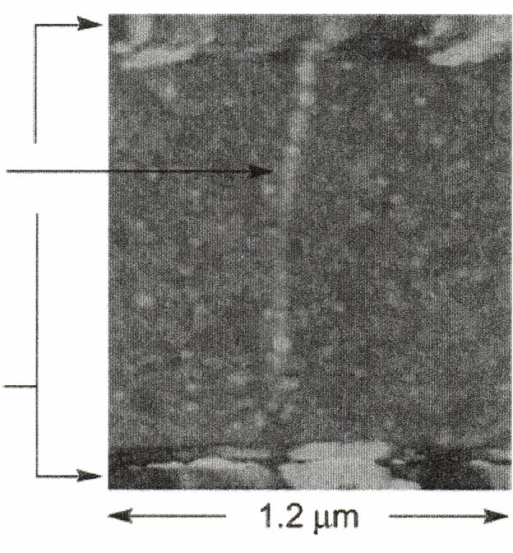
Nanotube
w/Protein
Ti/Au
electrode
Figure 3. AFM image of the polymer-coated and biotinylated
NTFET after exposure to streptavidin labeled with gold nanopar-
ticles (10 nm diameter).

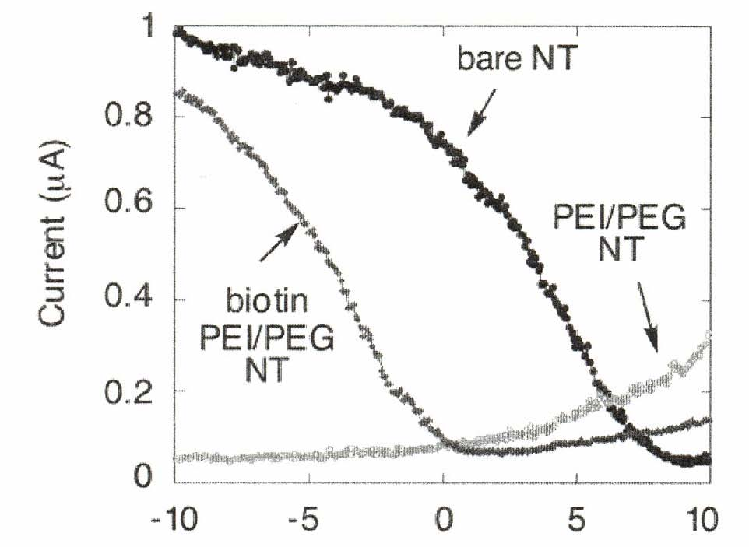
Gate Voltage (V)

Figure 4. Gate voltage dependence of the source-drain current I_{sd}
of a typical device before and after PEIPEG polymer coating and after biotin attachment to the polymer layer.
Next we discuss the change of the device characteristic
in response to the steps we have taken. The device characteristic before chemical modification is p-type, in an ambient environment, presumably due to exposure to oxy-gen.¹⁶ Coating the device with the mixture of PEI and PEG polymers results in an n-type device characteristic (Figure
4). This effect, which has been observed¹⁰ before, probably results from the electron donating property of the NH₂ groups of the polymer. The electronic characteristic of the device after 18 h of biotinylation reaction is also depicted in Figure
4. Attachment of biotin is through covalent binding to the primary NH2 group, thereby reducing the overall electron donating function of PEI and leading to a device character-istic that is consistent with removal of electrons from the device. As only the primary NH2 sites are involved in binding to biotin, the p-type conductance observed before coating is not fully recovered.¹⁷
The effect of exposing the biotinylated polymer-coated device to a streptavidin solution and the control experiments (conducted on different devices) are shown in Figure 5.
Figure 5a shows a striking loss of source-drain current for negative gate voltages after exposure to streptavidin and consequent streptavidin-biotin binding with little evidence for the shift of the device characteristic toward negative or positive gate voltage. Several control experiments were performed to demonstrate the effectiveness of the device architecture in avoiding false positives and in detecting specific protein binding. First, we have exposed the uncoated NTFET device to streptavidin and have found a change of the device characteristic, as shown in Figure 5b, indicating attachment of streptavidin to the device. Note, however, that in this case the primary effect is the shift of the device characteristic toward negative gate voltage. In contrast, when the device was polymer-coated, but not biotinylated, no changes occurred upon exposure to streptavidin (Figure 5c). This suggests the effectiveness of the polymer coating in preventing direct, nonspecific interaction of streptavidin with the nanotube. Finally, addition of a streptavidin in which
the biotin-binding sites were blocked by complexation with excess biotin produced essentially no change in device characteristic of the biotinylated polymer-coated device (Figure 5d).
Nano Lett., Vol. 3, No. 4, 2003 461
Several conclusions on the effect of biomolecules on the device electronics can be drawn. First, exposing the bare, uncoated device to streptavidin leads to the shift of the transconductance toward negative gate voltages, thereby rendering the device less p-type, with little reduction in the magnitude of the transconductance. This indicates that the primary effect of the nanotube-streptavidin binding is a charge-transfer reaction with streptavidin donating electrons to the nanotube.¹⁶ Biotin-streptavidin binding has a different effect; in this case the I_{sd} is reduced. We suggest that upon streptavidin-biotin binding, geometric deformations occur, leading to scattering sites on the nanotube, and thus to
reduced conductance. At the same time the device charac- teristic is modified only for negative gate voltages (see Figure 5a), leaving the transconductance in the positive gate voltage region unaffected. We have observed17similar features in devices to which charge carders were deposited, and we have argued that the observation is due to localization (delocal-ization) of positively (negatively) charged ionic entities by a negatively (positively) charged surface. Such a mechanism may also be effective here, and the mechanism may open
the way for electronic modification of bioreactions.
With improvements in NTFET devices, they may also be rendered sensitive enough that single protein detection and monitoring can be achieved. As can be inferred from Figure 5a, the total change in transconductance exceeds the noise level by a factor of 10. According to an AFM image of the device (Figure 3), there are about 100 gold nanoparticles,
and approximately 100 protein molecules (assuming one protein per gold nanoparticle binding to the tube) in close proximity to the carbon nanotube. Combining these two numbers, our current detection level can be estimated to be
of the order of 10 streptavidin molecules. Similar detection sensitivity can be inferred from experiments we have conducted on uncoated nanotubes incubated with streptavidin (Figure 5b). This is in contrast to the relatively modest

Figure 5. Change of the device characteristic upon exposure to streptavidin. Different devices with similar characteristic as observed
before polymer coating were used for a, b, and c. (a) Gate voltage dependence of the biotinylated, polymer-coated NTFET in the
absence and in the presence of streptavidin. (b) Current-voltage dependence of the bare NTFET device to nonspecific protein
binding. (c) of the polymer-coated NTFET device in the absence and presence of streptavidin. (d) of the biotinylated, polymer-
coated NTFET device in the absence and presence of streptavidin that was preincubated with biotin.

change observed in devices where the active element is a nanowire⁵ - a channel with a substantially larger cross
section.
Electronic sensing using devices with nanotubes as the conducting channel offers several advantages. Such sensors are small and fast, and the active detection area is sized for individual proteins or viruses. These sensors are extremely sensitive, as all the current passes through the detection point. Most importantly, at a later stage the devices can be made specific to individual molecules; potentially their response to different species can be varied in a controlled way using chemical and biological functionalization.
These concepts could conceivably be extended at a later stage to include cell-based electronic sensing (measuring the electronic response of living systems) and to using nanoscale devices for in-vivo applications (studying cell physiology, medical screening and diagnosis). The devices can be turned into devices where, by applying a voltage between elements of the sensor, surface charges can be created on the sensing element where the bio-molecules are immobilized. Such surface charges will interact with the charged biomolecules affecting biological function. Our experiments on that aspect
462 Nano Lett., Vol. 3, No. 4, 2003


of the electronic device-biology interface will be reported in a subsequent publication.
Acknowledgment. We thank M. Kubr, S. Kwan, D.
Olson, and C. Sun for their help in device fabrication, and T.-R. Han for assisting with the experiments.
Supporting Information Available: An AFM image of a typical semiconducting nanotube device is presented in Supporting Information. The device characteristic at different stages of the biotinylation reaction is presented. This material is available free of charge via the Internet at http:// pubs.acs.org.
References
(1) Bachtold, A.; Hadley, P.; Nakanishi, T.; Dekker, C. Science 2001,
294, 1317-1320.
(2) Martel, R.; Schmidt, T.;Shea, H. R.; Hertel, T.; Avouris, Ph. Appl.
Phys. Lett. 1998, 73, 2447.
(3) (a) Collins, P. G.; Bradley, K.; Ishigami, M.; Zettl, A. Science 2000,
287, 1801. (b) Kong, J.; Franklin, N. R.; Zhou, C.; Chapline, M. G.;
Peng, S.; Cho, K.; Dai, H. Science 2000, 287, 622. (c) Chen, R. J.;
Zhang, Y.; Wang, D.; Dai, H. J. Am. Chem Soc. 2001,123, 3838-
3839.
- (4) Shim, M.; Kam, N. W. S.; Chen, R. J.; Li, Y.; Dai, H. Nano Lett.
2002, 2, 285-288.
- (5) Cui, Y.; Wei, Q.; Park, H.; Lieber, C. M. Science 2001, 293, 1289-
1292.
- (6) Balavoine, F.; Schultz, P.; Richard, C.; Mallouh, V.; Ebbesen, T.
W.; Mioskowski, C. Angew. Chem., Int. Ed. Engl. 1999, 38, 1912 -
1915.
- (7) Gmner, G.;Gabriel, J.-C.; Zocchi, G., unpublished.
  - (8) (a) Baker, S. E.; Cai, W.; Lasseter,T. L.; Weidkamp, K. P.; Hamers,
R. J. Nano Lett. 2002, 2, 1413-1417. (b) Huang, W.; Taylor, S.;
Fu, K.; Lin, Y.; Zhang, D.; Hanks, T. W.; Rao, A. M.; Sun, Y.-P
Nano Lett. 2002, 2, 31 1-314.
  - (9) (a) Star, A.; Stoddart, J. F.; Steuerman, D.; Diehl. M.; Boukai, A.;
Wong, E. W.; Yang, X.; Chime, S. W.; Choi, H.; Heath, J. R. Angew.
Chem., Int. Ed. 2001, 40, 1721-1725. (b) O'Connell, M. J.; Boul, P.;
Ericson, L. M.; Huffman, C.; Wang, Y. H.; Haroz, E.; Kuper,
C.; Tour, J.; Ausman, K. D.; Smalley, R. E. Chem. Phys. Lett. 2001,
342, 265 - 271. (c) Star, A.; Steuerman, D. W.; Heath, J. R.; Stoddart,
J. F. Angew. Chem., Int. Ed. 2002, 41, 2508-2512.
- (10) Shim, M.; Javey, A.; Kam, N.W. S.; Dai, H. J. J. Am. Chem. Soc.
2001, 123, 11512-11513.
- (11) Ostuni, E.; Chapman, R. G.; Holmlin, R. E.; Takayama, S.;
Whitesides, G. M. Langmuir 2001, 17,5605-5620, and references
- therein.
- (12) (a) Miyamoto, S.; Kollman, P. A. Proteins Struct. Fund. Genet.1993,
- 16, 226-245. (b) Vajda, S.; Weng, Z.; Rosenfeld, R.; DeLisi, C.
Biochemistry 1994, 33, 13977-13988.
- (13) Star, A.; Han, T. R.; Gabriel, J.-C.; Bradley, K.; Gmner, G.
“Electronic Detection in Liquids Using Nanotube FET Devices",
submitted for publication.
- (14) NTFETs were fabricated using nanotubes grown by chemical vapor
deposition, directly on 4" silicon wafers (with 200 nm films of
thermal Si02) using a home-built apparatus. In a typical experiment,
the wafer is covered with patterned photoresist and is spin coated
with growth promoter containing nanoparticles of iron encased within
a mesoporousmaterial [(a) Li, W. Z.; Xie, S. S.; Qian, L. X.; Chang,
B. H.; Zou, B. S.; Zhou, W. Y.; Zhao, R. A.; Wang G. Science 1996,
274, 1701-1703, (b) Pan, Z. W.; Xie, S. S.; Chang, B. H.; Wang,

C. Y.; Lu, L.; Liu, W.; Zhou, W. Y.; Li, W. Z.; Qian, L. X. Nature
1998, 394, 631-632]. After liftoff in acetone, small patterned areas
of the growth promoter are left on the wafer. The wafer is then
introduced in a 5 in. tubular oven and treated at 900 ^{O}C in a methane
and hydrogen flow for 15 min, allowing for the growth of SWCNT
of 5-10 pm long and 1.5 to 3 nm in diameter. The hydrogen helps
|to prevent the deposition of amorphous carbon around the nanotubes
as well as on the surface of the silicon [Ivanov V.; Nagy, J. B.;
Lambin, Ph.; Lucas, A,; Zhang, X. B.; Zhang, X. F.; Bernaerts, D.;
Van Tendeloo, G.; Amelinckx, S.; Van Landuyt, J. Chem. Phys. Lett. 1994, 223, 329-335]. Standard optical lithography and metal
deposition are used to form the metal contacts on top of the grown nanotubes. A fair proportion of the tens of thousands of devices made
on each wafer are p-type FETs with a modulation of 1, indicating
that only semiconducting nanotubes are present. The devices used
in this study were selected from among those. An AFM image of a
typical device is presented in Supporting Information.
- (15) Streptavidin is labeled with gold nanoparticles for the purpose of
AFM imaging. Streptavidin (from Streptomyces avidinii, Sigma
Chemicals) without gold labeling had similar effect on the device
characteristic but could not be detected by AFM.
- (16) (a) Jhi, S.-H.; Louie, S. G.; Cohen, M. L. Phys. Rev. Lett. 2000, 85,
- 1710-1713. (b) Ulbricht, H.; Moos, G.; Hertel, T. Phys. Rev. B 2002,
66, 075404.
- (17) The progress of the on-chip biotinylation reaction can be monitored
by measuring. Biotin-N-hydroxysuccinimide ester reacts
readily with primary amines in PEI under ambient conditions, thus
reducing the electron donating of PEI. However, after 1 h the yield
of the reaction is only -75%; several hours are required to complete
the reaction. The device characteristic at different stages of the
biotinylation reaction is presented in Supporting Information.
- (18) Wilchek, M.; Bayer, E. A. Methods Enzymol. 1990, 184, 49.
- (19) Cumings, J.; Star, A.; Gabriel, J.-C.; Bradley, K.; Griiner, G.
"Influence of Mobile Ions on Nanotube Based FET Devices",
submitted for publication.
- NL0340172

Nano Lett., Vol. 3, No. 4, 2003 463

